RocketCX User Guide

ECS-RCX-UG

# Document Control

## Details of Authorship

|  |  |
| --- | --- |
| Name(s)  Title(s)  Organisation | Sachin Gawas  Senior Developer  ECS |

## Version Control

|  |  |  |  |
| --- | --- | --- | --- |
| **Version** | **Date** | **Author** | **Changes & Reason for Change** |
| 1.0.0 | 19/11/2019 | Sachin Gawas | Initial release |
|  |  |  |  |

Contents

1. Document Control 1

1.1 Details of Authorship 1

1.2 Version Control 1

2. Introduction 4

2.1 Features 4

2.2 Benefits 5

3. User Roles 6

4. Browser Requirements 6

5. Accessing the RocketCX Tool 7

6. Contact Control Panel Components 12

6.1 Status 13

6.2 Tabs 14

6.2.1 Favourite Contacts 14

6.2.2 Contacts 14

6.2.3 Dial Pad 15

6.2.4 Call History 15

6.2.5 Active Call 16

7. Telephony Operations 17

7.1 Incoming call 17

7.2 Outgoing call 20

7.2.1 Click to Dial 21

7.3 Creating a related record 22

7.4 Opening a Related Record and User record 23

7.5 Disposition Code 24

8. Call Logs and Recordings 25

8.1 Call Log 25

8.2 Call Recording Player 26

9. Reporting 27

9.1 Service Centre Dashboard 27

9.2 Supervisor Dashboard 28

9.2.1 Historic Reports 28

9.2.2 Today’s Trends 28

9.2.3 Agent Report - Historical 29

9.2.4 Agent Report – Today’s Trend 29

9.3 My Dashboard 30

10. Administration 31

10.1 Create Amazon Connect Queue Records in ServiceNow 31

10.2 Configure Admin Console 32

10.2.1 Amazon Connect 32

10.2.2 ServiceNow 34

10.2.3 RocketCX 36

10.3 Disposition Codes 37

11. Application Logs 38

11.1 System Logs 38

12. Support 39

13. Glossary 39

# Introduction

‘RocketCX Enterprise Connector for ServiceNow (RocketCX)’ integrates Amazon Connect with ServiceNow providing a rich computer telephony integration between one of the most innovative cloud contact centre technology and your favourite CRM.

RocketCX makes contact centre agents more efficient, reduces call costs and improves customer experience.

## Features

* **ServiceNow Integration** – All standard call handling features available natively within the ServiceNow interface. This includes Answer, Ignore, Place on hold, Consult, Transfer, Conference and Manage Agent Status.
* **Intelligent Dialling** – Click on any telephone number or contact field within ServiceNow to make an outbound call. RocketCX intelligently handles country and dialling codes providing a one-click dialling experience for outbound contact centres. Create favourites within RocketCX for even faster access.
* **Screen Pop** – Display caller details along with any open incidents or cases before the call is answered, enabling the agent to provide a warm start to the call.
* **Automated Call Logging & Recording** – Call logs are created automatically capturing contact and agent details, call duration, summary, notes, disposition codes, customer satisfaction score and access to a full recording of the call.
* **Create Record** – Create ServiceNow Incidents and Cases from within the RocketCX interface linking contacts, call logs and call recordings automatically.
* **Reporting & Dashboards** – Real-time service centre dashboards and historical trend reports provide the visibility supervisors need, to manage their teams, all within ServiceNow.

## Benefits

* Telephony system integration with ServiceNow eliminating frequent screen switching to make and receive calls
* Outbound calling by clicking on the user in ServiceNow eliminating manual dialling effort
* Reports, Metrics and Dashboard to assess Service Centre performance
* Call records available on Servicenow to review agent performance

RocketCX is available for ServiceNow IT Service Management, HR Service Management and Customer Service Management.

# User Roles

There are three roles for RocketCX.

|  |  |
| --- | --- |
| Role Label | Description |
| Plug-In Administrator | Users in this role group will have access to all functions on the Admin Console and Administration menu. This is accessed through the ServiceNow back end. |
| Contact Centre Supervisor | Users in this role group have access to the queue and agent reporting functions (for all agents), and the Service Centre Dashboard. |
| Contact Centre Agent | Users in this role group will have access to the Contact Control Panel (CCP) and will also be able to access the agent reporting function for their own user ID only. |

Note: *RocketCX is CTI application which runs on ServiceNow with OpenFrame plugin dependency. ServiceNow Administrator must assign sn_openframe_user role to any ServiceNow user with Contact Centre Agent role. Users with Contact Centre Agent role must be assigned roles or membership of ServiceNow groups which provide access to the ServiceNow modules (Incident, Customer Service and HR Core) supported by RocketCX.*

# Browser Requirements

RocketCX is designed to work with the latest version of Google Chrome.

# Accessing the RocketCX Tool

The following steps outline the process to access the CCP by an agent, in order to be able to make/receive calls and access contacts:

1. Log in to ServiceNow.

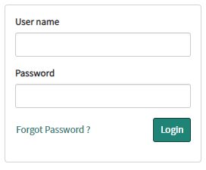

1. Once logged in to ServiceNow, click on the phone icon which will open the CCP window.



1. In the CCP window, click on *Sign in to CCP* which will open an Amazon Connect window.

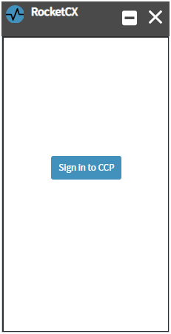

1. Enter your Amazon Connect credentials and click on *Sign In*

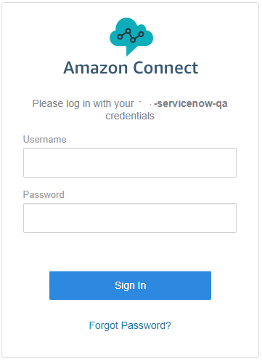

1. Once you have logged in, it will close the window and ask for audio and microphone permission for the browser. Click on Allow.

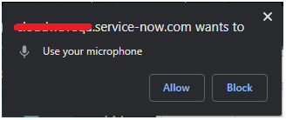

1. RocketCX CCP will now display agent name and status:

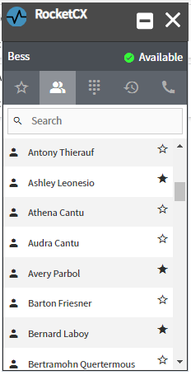

Agents can open the CCP using three different methods:

1. From the ServiceNow instance home page.

Click on the phone icon as shown in below screenshot



1. From a User Record.

Open a User record as shown in the following screenshot and click on the phone icon.

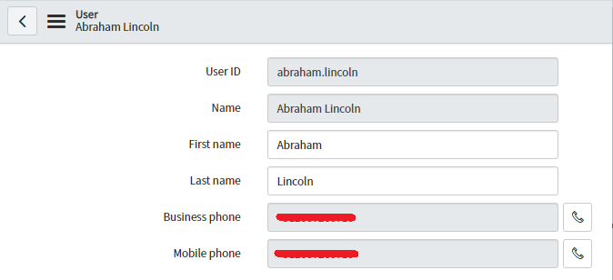

1. From the Incident/CSM and Case/HR Case forms.

Open an Incident or Case as shown below, and click on the phone icon.

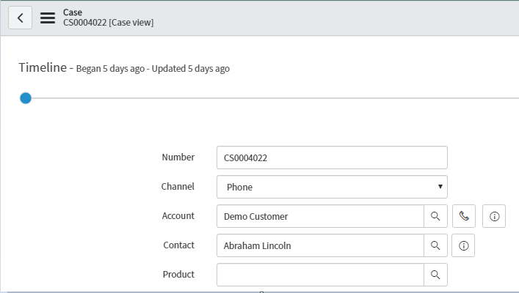

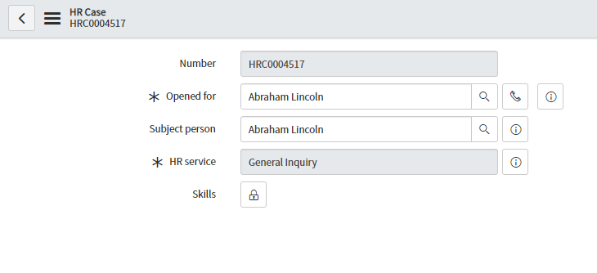

**Note:** The *user should have the required roles in order to access the Incident, Customer Service, HR Case modules.*

# Contact Control Panel Components

RocketCX CCP displays four components:

* Name of Agent logged in
* Status
* Tabs
* Tab content

RocketCX CCP window can be minimised/maximised using the buttons displayed in the top corner of CCP.



Agent Status

Tab Content

Tabs

Agent Name

## Status

The agent can change the availability status using the status dropdown. The possible status values are:

1. Available
2. Busy
3. Do not disturb
4. Offline

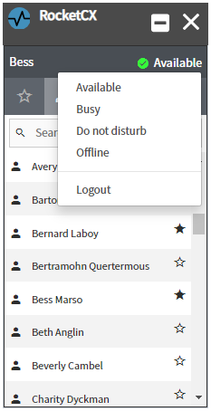

**Note**: *You can also logout from Amazon Connect using the logout link given on the status dropdown. Calls will only be received when the status is set to Available.*

## Tabs

### Favourite Contacts

The agent can click on the Star Icon, to add the contact to the Favourites tab.

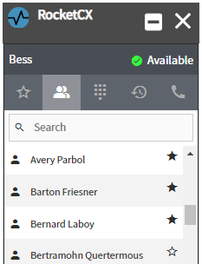

Favourites

### Contacts

The Contacts tab displays a list of contacts assembled from the contact tables defined in the Admin Console like Users, Contacts or Consumers.

Outgoing calls can be placed by clicking on a contact. If two numbers are associated with a contact, CCP will then display a popup to choose a number (as shown below):

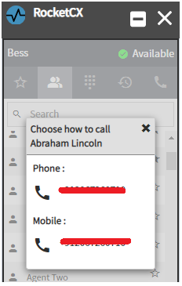

### Dial Pad

The Dial Pad can be used to place an outgoing call to a number which is not listed in ServiceNow:

. 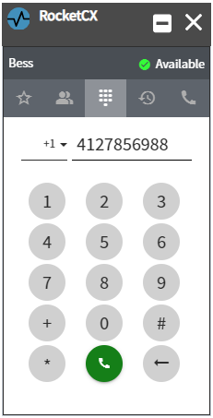 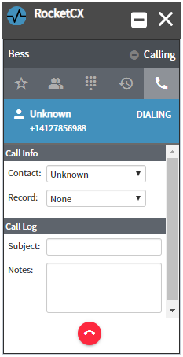

### Call History

Call History shows the last 50 entries for calls placed or received using the CCP. Each call entry contains date, time, caller and incoming or outgoing details:

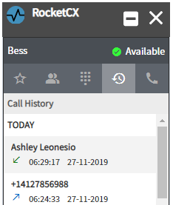

Call History

### Active Call

The Active Call tab is displayed automatically when an agent receives an incoming call or makes an outgoing call on CCP. The Agent cannot select this tab manually.

As shown below, the tab displays caller details like name and any related records (in the Record dropdown). Note that the agent can also add call log details on wrap-up.

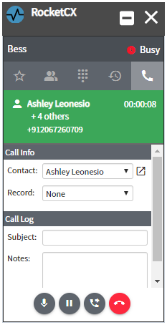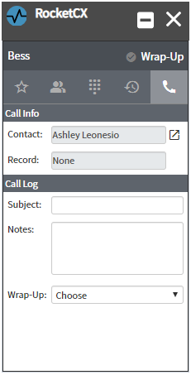

# Telephony Operations

## Incoming call

When a customer calls to the Amazon Contact Centre, the call is routed to the next available agent, based on inputs from the customer. The call will flash on the CCP, as shown below. The agent can accept or reject the call by selecting the relevant button:

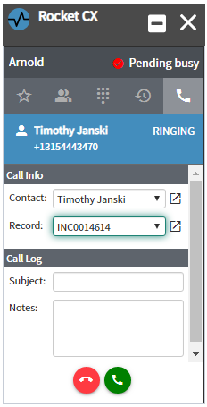 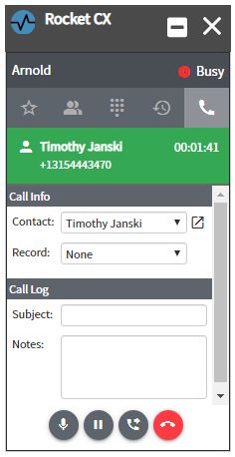

Hold the call

Accept the call

Reject the call

Transfer call

The Incoming call will display the name or contact number of the customer, and a user record if one exists.

The Agent can transfer a current call to another Agent in the queue. Also, once transferred, Agent can switch between calls using swap button available on CCP. In addition, Calls can be put on hold or joined to a conference.

**First Agent** **Second Agent**

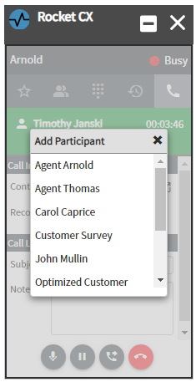 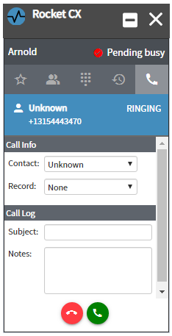

Select Agent or Queue to transfer

**Switched Call Conference**

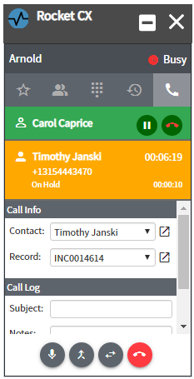 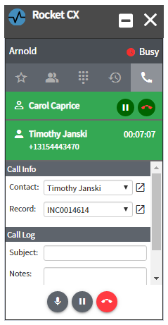

Hold

Mute

Merge

Swap

## Outgoing call

The Agent can make outgoing calls from the Contacts tab, or by using the dial pad to enter a phone number plus country code. The CCP will also display related records for the Contact selected for an outgoing call.



### Click to Dial

“Click to dial” makes calling easier and faster for your agents, with no time wasted on misdials. When the agent clicks on any phone field, the number is automatically dialled using the CCP. The Agent can use click to dial from the User table form and incident, CSM case or HR Case record form, as shown below. Click to dial will also work if you click on the phone icon from the home window of ServiceNow, which will open CCP and dial the number for the selected contact.





If agent clicks on the phone icon, it opens the CCP and dials the number

## Creating a related record

The Agent can create a new Incident, CSM Case or HR Case using the + button next to the related record box on the CCP. This button will only appear on an active call when a subject is provided in the Call Log section. The subject will be used as a short description for the related record.

The type of record (Incident or Case) can be selected from the dropdown. When the + button is clicked, a new record for the customer will be created in ServiceNow.

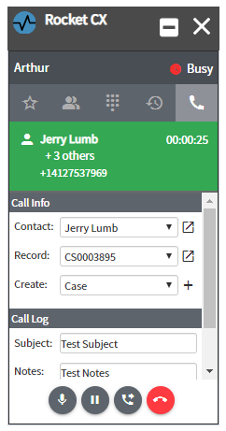

Using this ‘+’ icon Agent can create new record

## Opening a Related Record and User Record

The Customer related record will flash in the CCP once the agent clicks on the  icon.

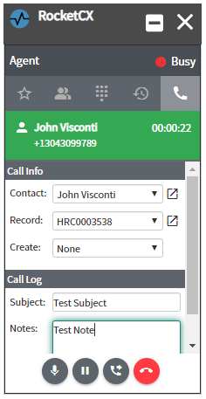

Opens the related record

Opens the User record

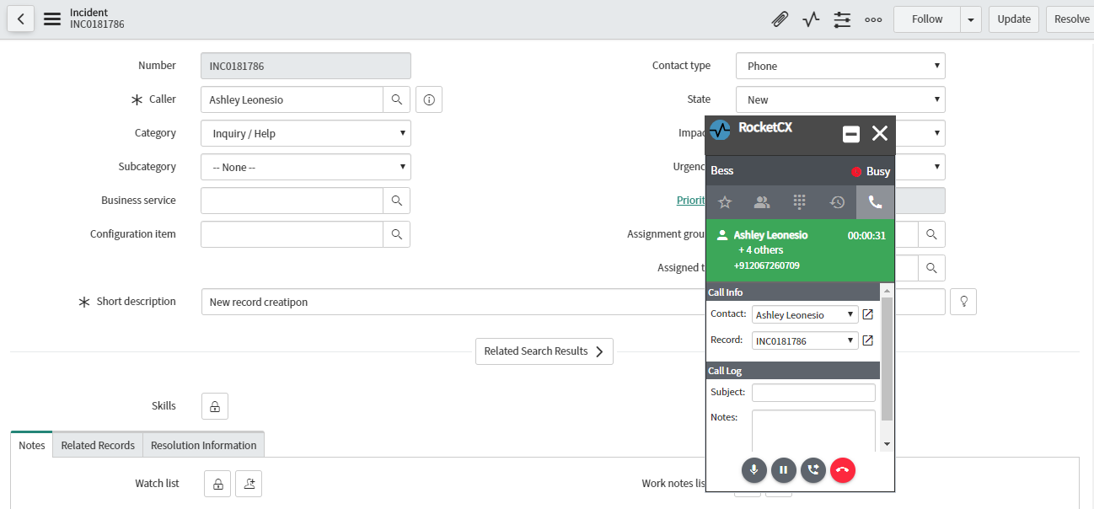

## Disposition Code

To conclude a call, a Disposition code is required which can be customised from the admin console (please refer section 10.3 in this document for more details). The Agent can add subject/notes and then save it for each incoming/outgoing call.

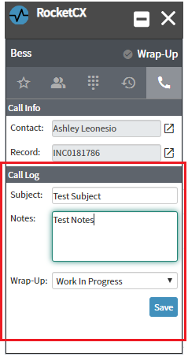

# Call Logs and Recordings

## Call Log

When an Agent ends a call and saves a disposition code, a call log record gets created which will record information like Contact ID, Agent, Start time, Duration of Call, Disposition Code, Call Recording etc.

Users with Contact Centre Supervisor role can access these call logs and call recordings:

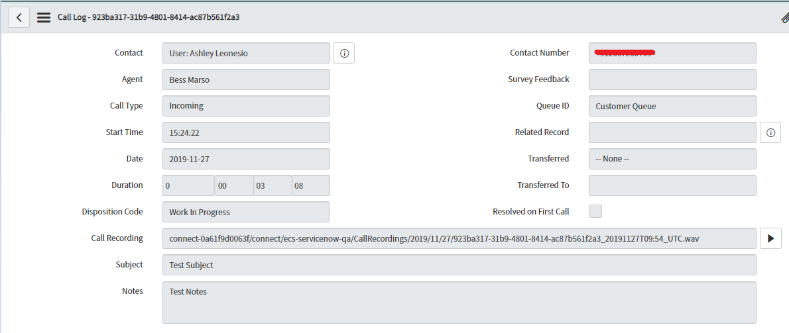

Call logs can be accessed from related records like Incident, CSM Case or HR Case from their work notes:

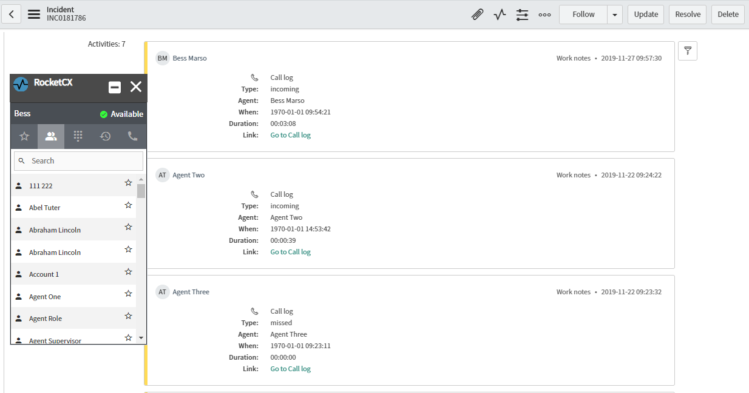

## Call Recording Player

The Contact Centre Supervisor can listen to the recordings using Call Recording Player embedded into ServiceNow:

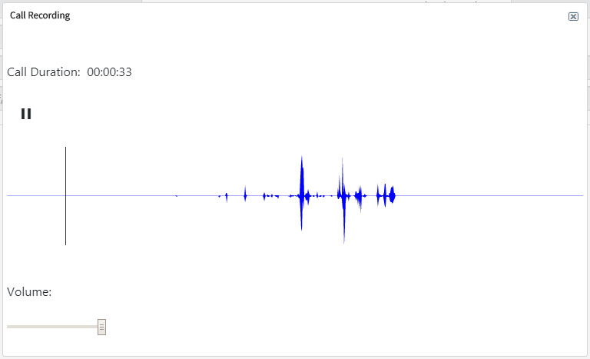

# Reporting

The RocketCX application provides a Service Centre Dashboard which displays both real-time and historical metrics from Amazon Connect, as well as ServiceNow Standard reports.

## Service Centre Dashboard

The Real-time Dashboard can be accessed by the Contact Centre Supervisor using the *RocketCX> Service Centre Dashboard* application menu, which loads a report as shown in the screenshot below.

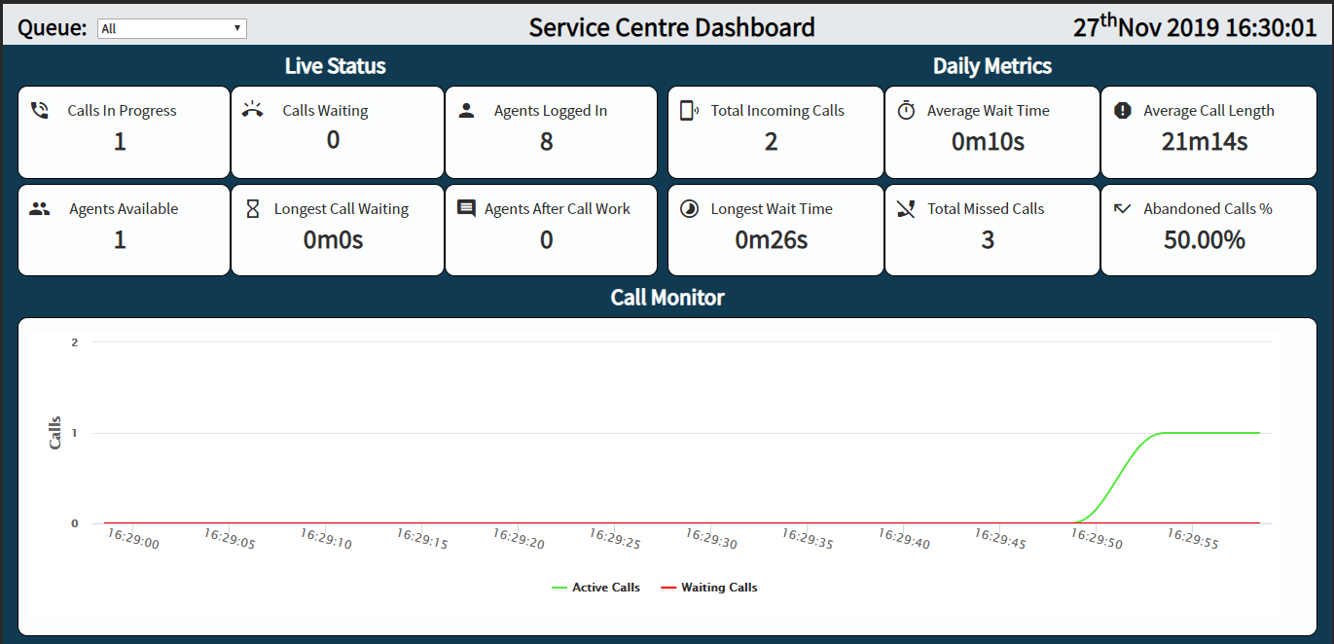

## Supervisor Dashboard

The Supervisor dashboard can be accessed by the Contact Centre Supervisor using *RocketCX> Supervisor Dashboard*

### Historic Reports

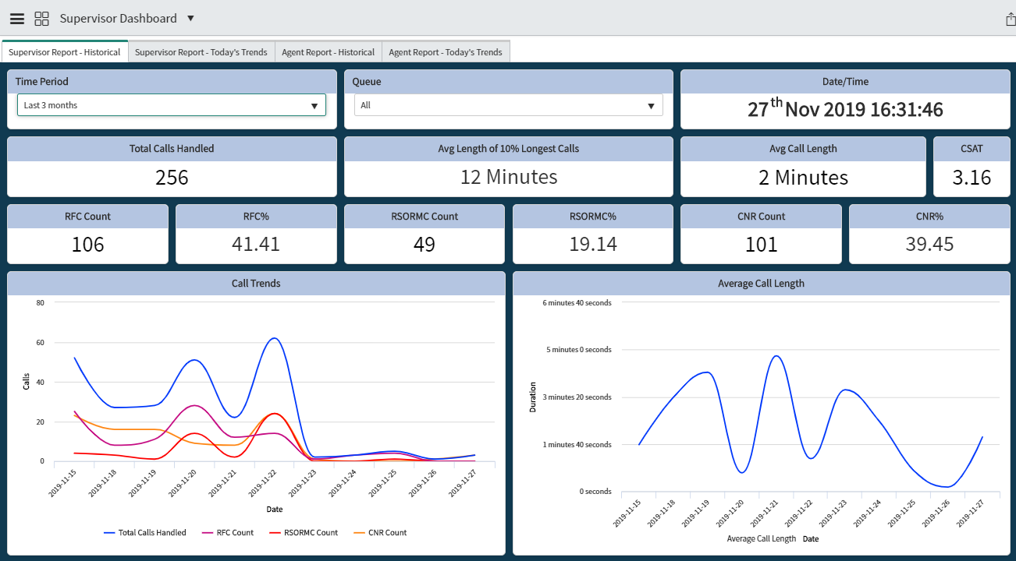

### Today’s Trends

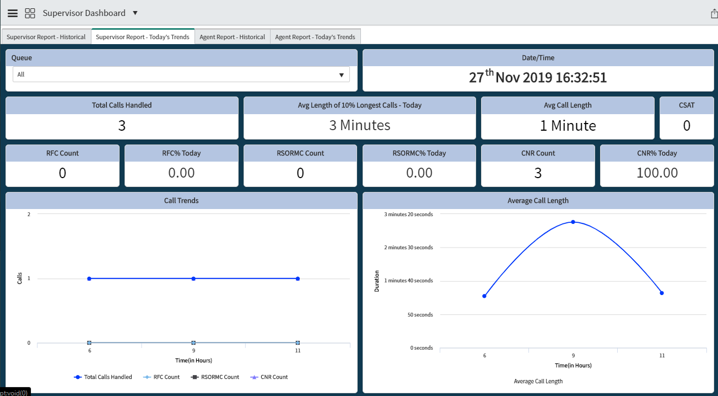

### Agent Report - Historical

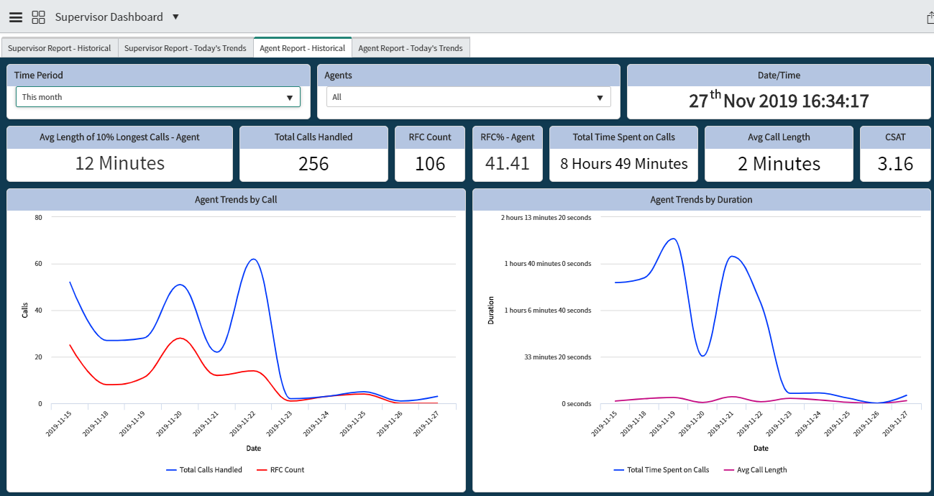

### Agent Report – Today’s Trend

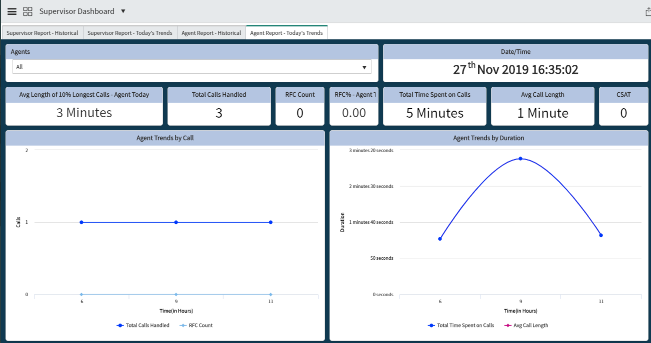

## My Dashboard

Users with Agent role can see their own metrics (Historical & Today’s) using *RocketCX> My Dashboard*

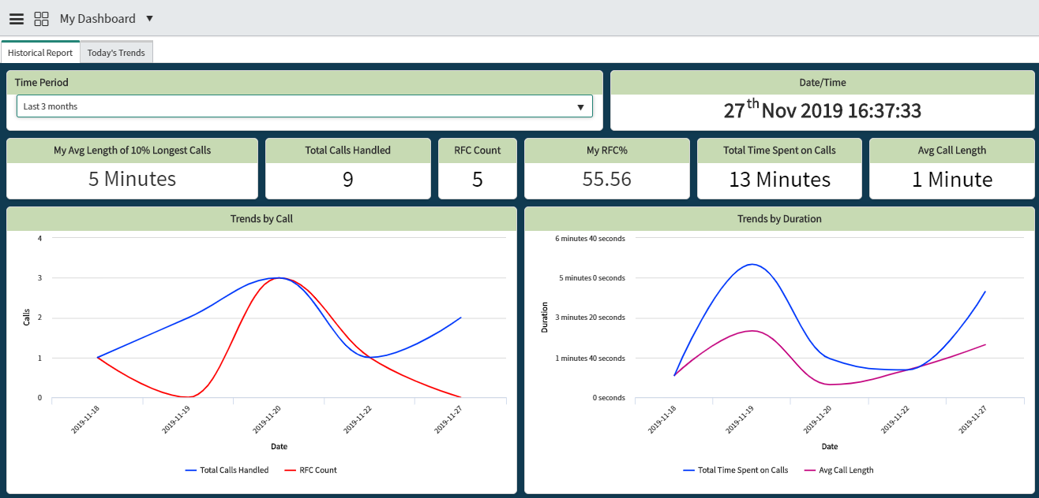

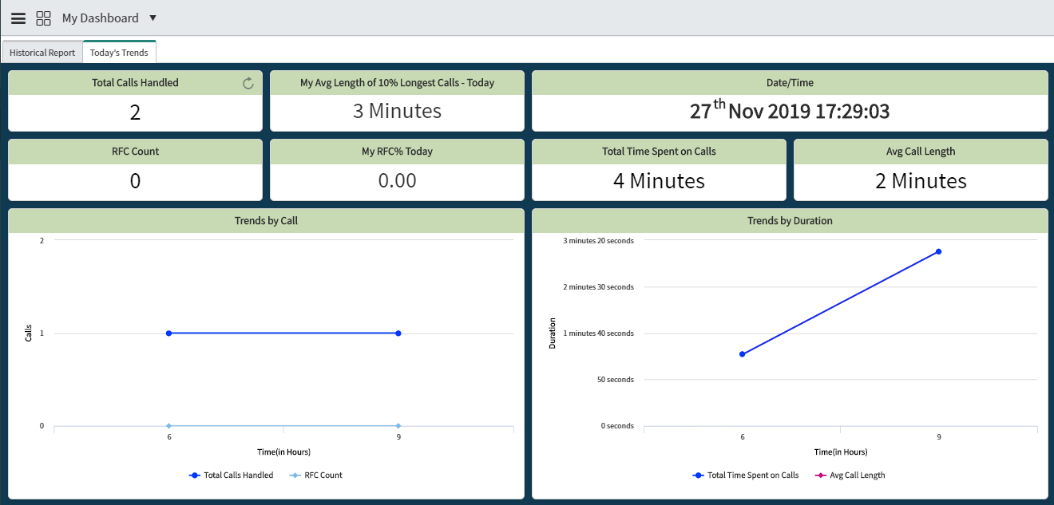

# Administration

## Create Amazon Connect Queue Records in ServiceNow

The Plug-in Administrator should add Connect Queues manually to enable RocketCX to fetch reporting metrics from Amazon Connect.

To create a Connect Queue, click on the button *New* to add the name, ID, ARN details and save the record. To edit, open an existing record from the list and update.

Users with Plug-In Administrator role can access Connect Queues using *RocketCX> Connect Queues*

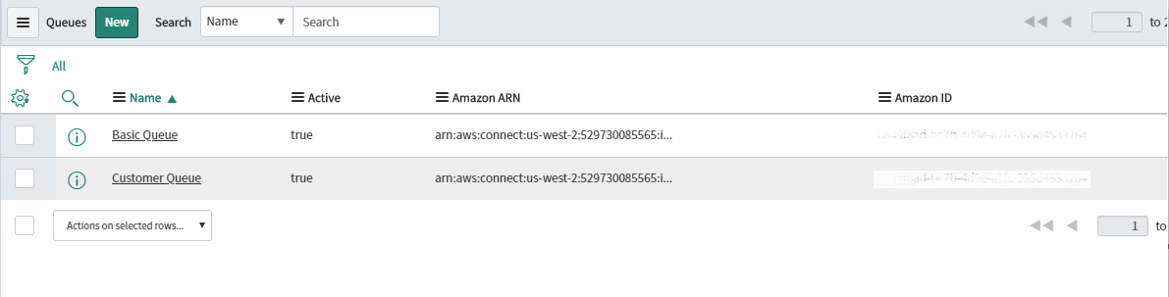

**Steps to create or edit Amazon Connect Queues:**

1. Click on button *New* and select the checkbox for Active. Enter the ARN, Queue ID/Amazon ID and name of the queue. Click on Submit.

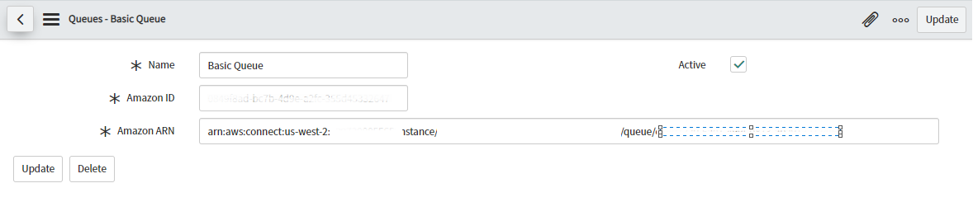

1. To edit an existing Connect Queue, click on the record from the list.

## Configure Admin Console

Log in as a Plug-In Administrator or If you have logged in as SNOW Administrator, change the application scope to RocketCX, search for RocketCX in the left navigation bar and click on Admin Console under the Administration module.

The Admin Console page will display three tabs: Amazon Connect, ServiceNow and RocketCX.

### Amazon Connect

The Amazon Connect tab contains the following mandatory properties which are required to set up connectivity between ServiceNow and Amazon Connect.

1. **Amazon Connect CCP URL:** URL to your Amazon Connect Instance CCP.
2. **S3 Bucket Name:** Name of S3 Bucket where call recordings are getting saved.
3. **S3 Bucket Region:** Region of S3 Bucket.
4. **Amazon Connect Instance Region:** Region of your Amazon Connect Instance.
5. **Amazon Connect Instance ID:** The Amazon Connect Instance ID can be found from Instance ARN.
6. **Amazon Connect Access Key ID:** Access Key ID will be used to gain programmatic (API) access to AWS services.
7. **Amazon Connect Secret Access Key:** SecretAccess Key will be used to gain programmatic (API) access to AWS services.

The Amazon Connect Access Key ID and Secret Access Key can be copied from the IAM User Account in AWS. Steps to set up IAM User are already mentioned under “AWS IAM User”

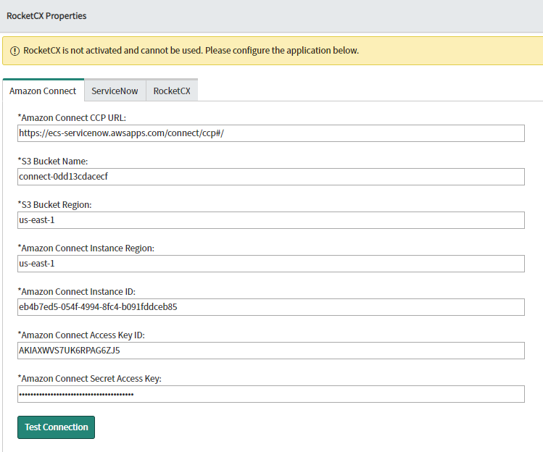

Once you have entered all the properties on the above tab, click on “Test Connection” button. If you get an error message, please correct them with the help of an AWS Admin.

### ServiceNow

The ServiceNow tab holds related record and contact table properties.

1. **Related** **Record tables:** RocketCX supports Incident Management, Customer Service and Human Resource Core modules. The Related Record Table control will display core tables from each module for selection.

On CCP, an Agent can see the related records for the modules selected under header Related Record Tables on ServiceNow tab of Admin Console

1. **Contact Tables:** Contact tables are available for selection based on the above-mentioned active modules. Contact tables will be used to display a list of contacts on the CCP.
2. **Enable Reporting:** This property enables the Service Centre Dashboard to display Real-time and Historical Metrics.

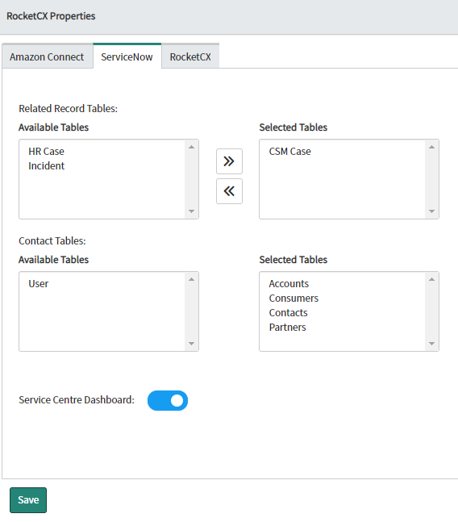

The administrator needs to select at least one related record table, which will allow CCP with access to different modules.

For example, if you want to enable CCP for the Incident module, you should select the Incident table from *Related Record Tables* and move it to *Selected Tables* from *Available Tables*.

On selecting the related record table, contact tables associated with it get automatically selected but this selection can be modified as per user’s requirement.

Steps:

1. Select the related record table on which you want to enable the CCP.
2. The Service Centre Dashboard can be enabled/disabled using the On/Off switch available on the ServiceNow tab of Admin console.



1. Validations are applied to mandatory fields. If the user tries to save the properties without entering details in any of the mandatory fields, the following message will be displayed.

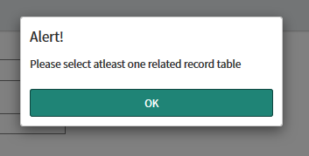

1. Click on the Save button; this will save the properties from the Amazon Connect and ServiceNow tabs.

### RocketCX

Usage of RocketCX CCP and Service Centre Dashboard is restricted until you have registered on the RocketCX site and configured a new Instance for ServiceNow. You will then need to provide the following properties:

* **RocketCX Username**: This is the username used while creating a new instance on RocketCX portal.
* **RocketCX Password**: This is the password used while creating a new instance on RocketCX portal.
* **RocketCX Instance ID**: This is the Instance ID generated once a new instance is created on RocketCX portal.

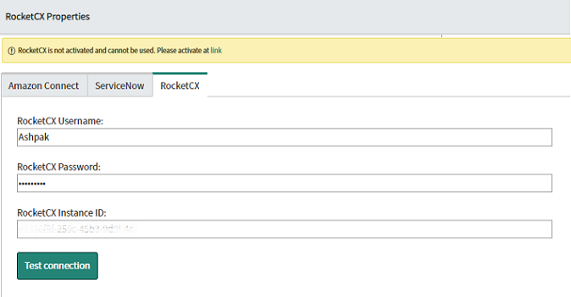

1. Click on the Test Connection button. If the connection is successful, you can save the properties.
2. Next, reload the page to start using RocketCX CCP and the Service Centre Dashboard.

## Disposition Codes

The Plug-In Administrator can add, modify or delete Disposition codes which will be used in CCP to store wrap up notes. The Plug-In Administrator is restricted from making any changes to ‘System Auto’ Disposition Codes.

Disposition Codes can be accessed using *RocketCX> Disposition Codes*

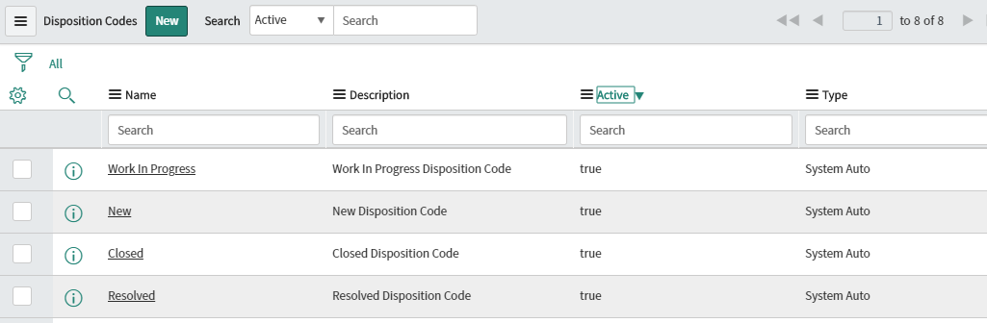

Steps to create or edit Disposition Codes:

1. Click on the New button, enter the name and description, and select the Active checkbox. Click on Submit.

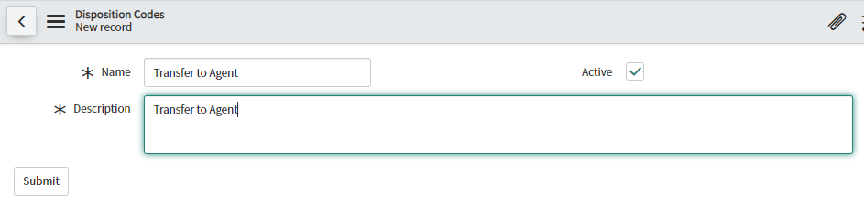

1. To edit an existing disposition code, click on the record from the list.

# Application Logs

Application logs contain both system logs and call logs. Call logs are covered as part of section 8.1 of this document.

## System Logs

The ServiceNow Administrator or Plug-In Administrator can access the System Logs module. This module store all the event logs related to RocketCX. The logs help the Administrator troubleshoot issues when something goes wrong in it.

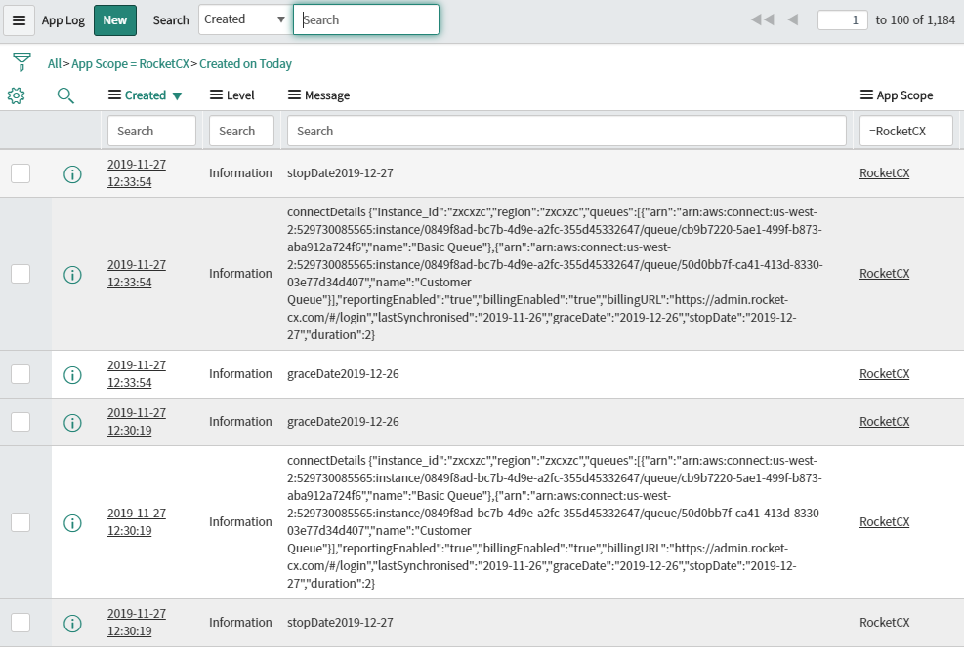

# Support

|  |  |
| --- | --- |
| Aspect | Details |
| Support Hours of Operation | 09:00 - 17:00 (GMT) |
| Support Days of Operation | Monday - Friday (excluding U.K Public Holidays) |
| Promised Response Time | Within 1 Business day of received support request |
| Promised Resolution Time | Within 15 Business Days of response |
| Contact Method | Email |
| Contact Details | RocketCX.support@ecs.co.uk |

# Glossary

|  |  |
| --- | --- |
| Terminology in use | Definition |
| CCP | Contact Control Panel |
| CTI | Computer Telephony Integration |
| CRM | Customer Relationship Management |